**STIBO Assignment**

**Exercise 01 : Define Category Level Object Types.**

**Solution:**

* First, Login to STEPworkbench.
* Then, Go to System setup -> Object Types & Structures -> Primary Product Classification -> Product -> define the products :

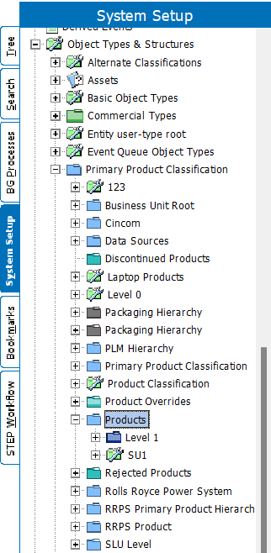

* Right-Click on Product to make new Product Object Type:

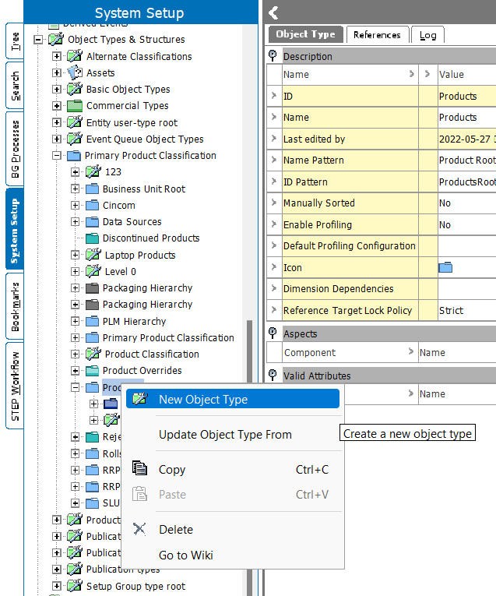

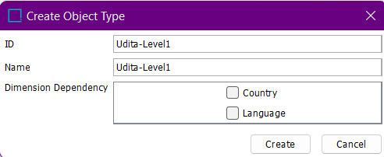

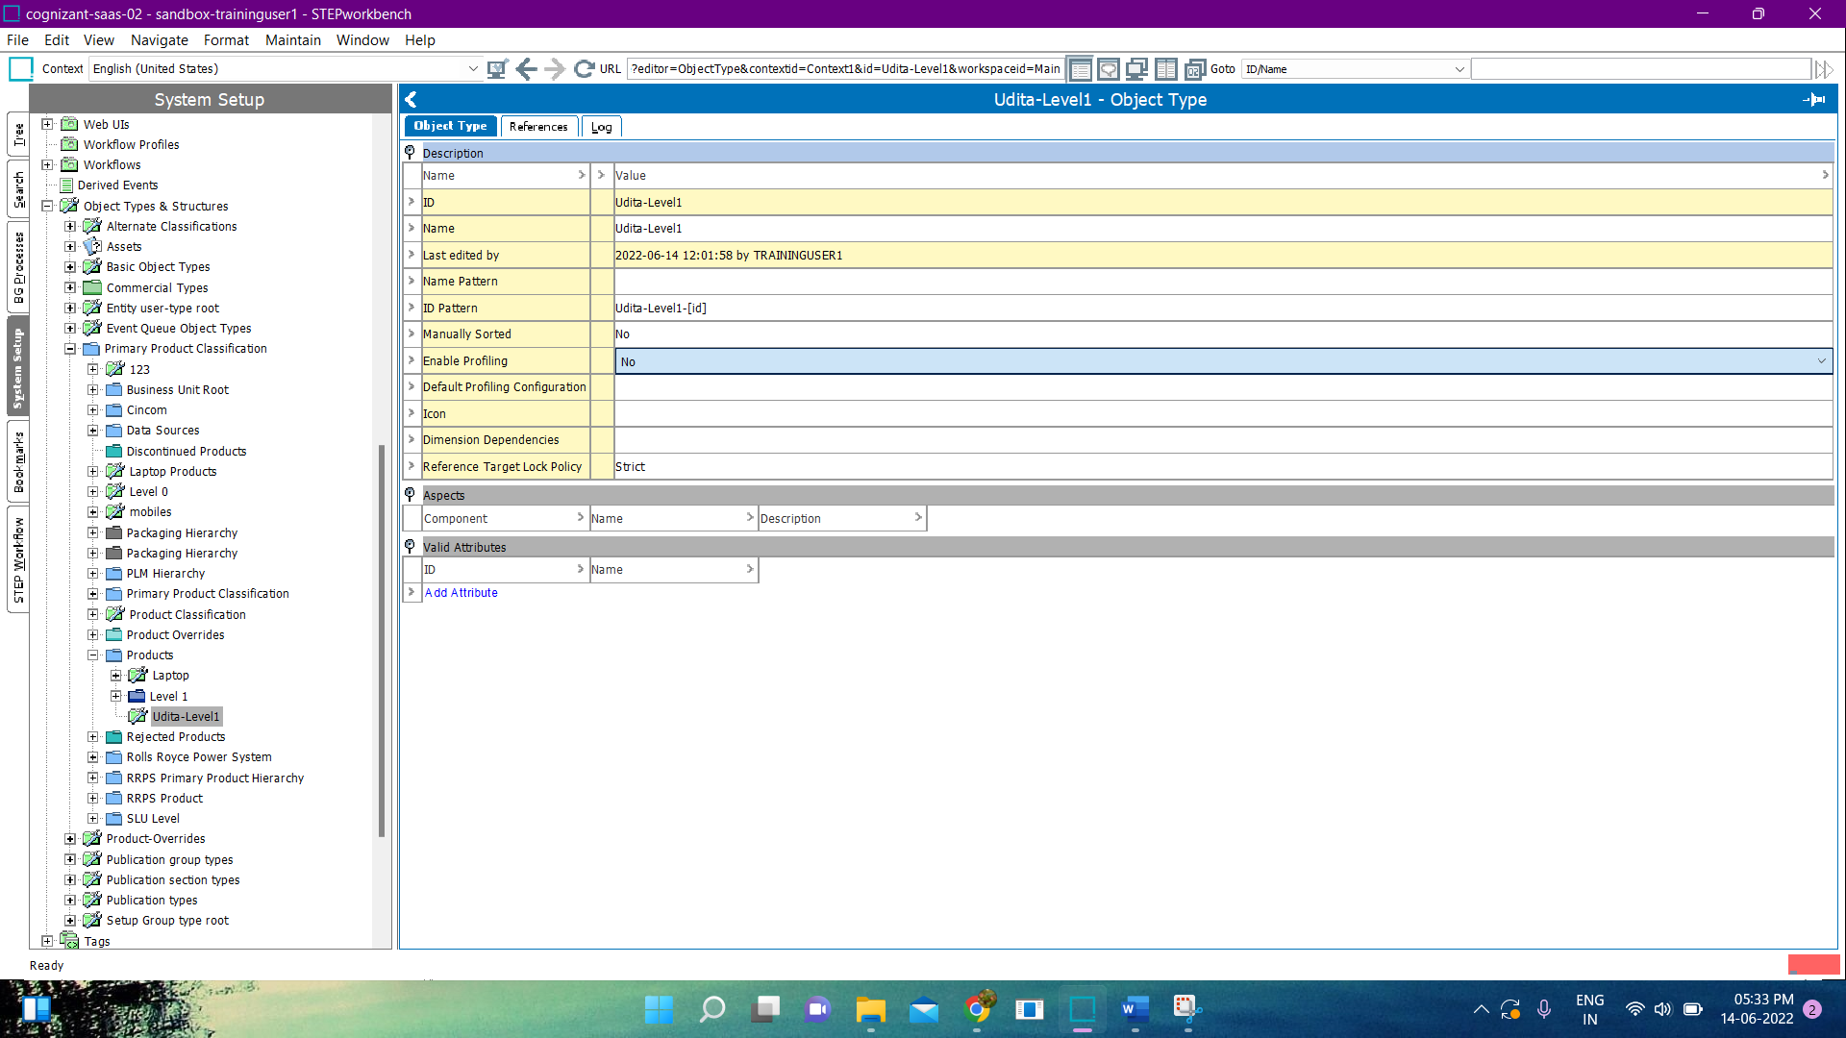

* Now, Select Udita-Level1 and create child object of it.

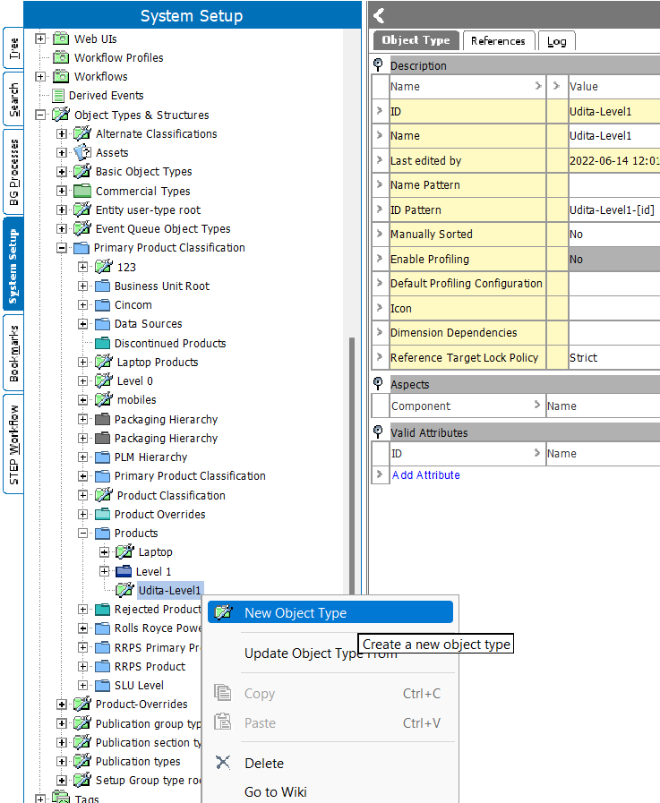

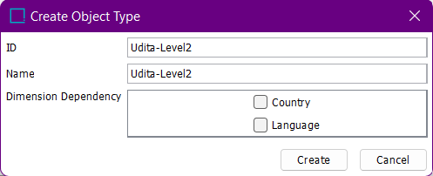

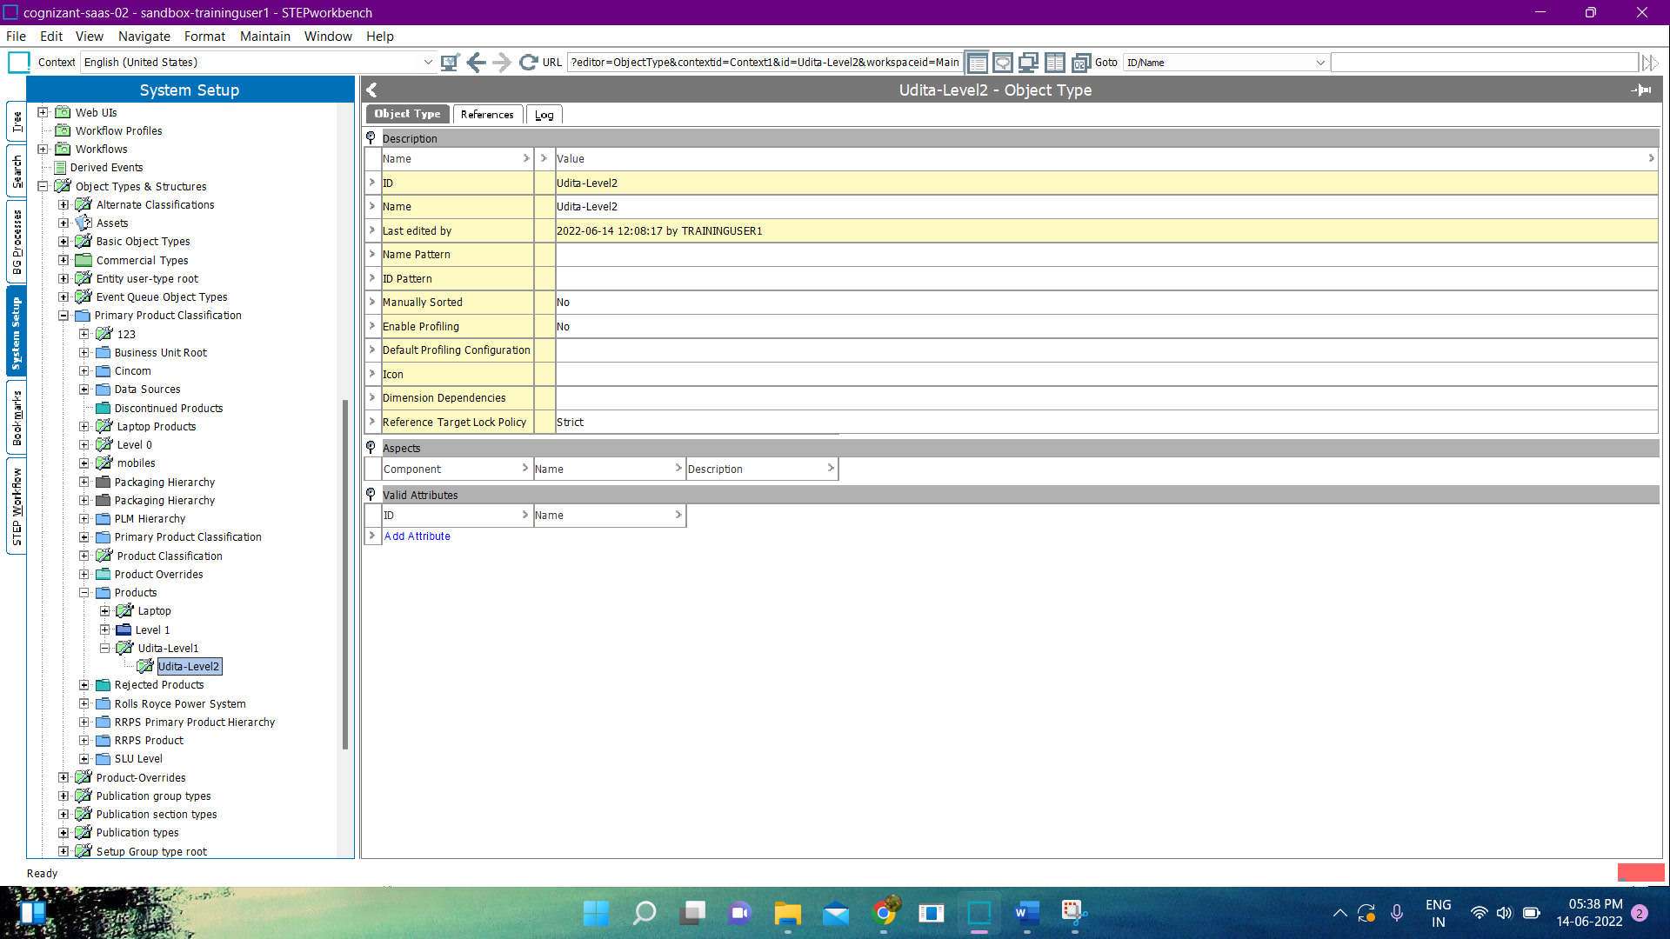

* The ID Pattern of each level are :
* Level 1:

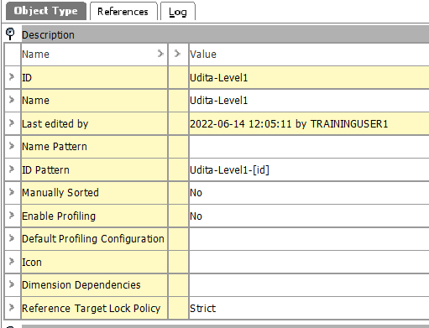

* Level 2:

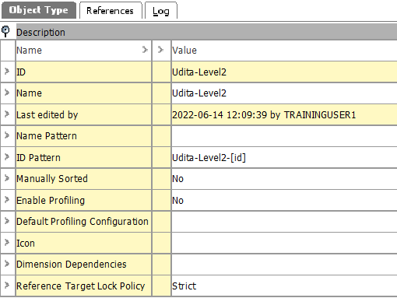

* Finally, it looks like :

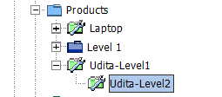

**Exercise 02 : Instantiate Top Category Levels.**

**Solution :**

* Go To Tree -> Primary Product Hierarchy.
* Right Click on Primary Product Hierarchy-> New Product-> Select Products.

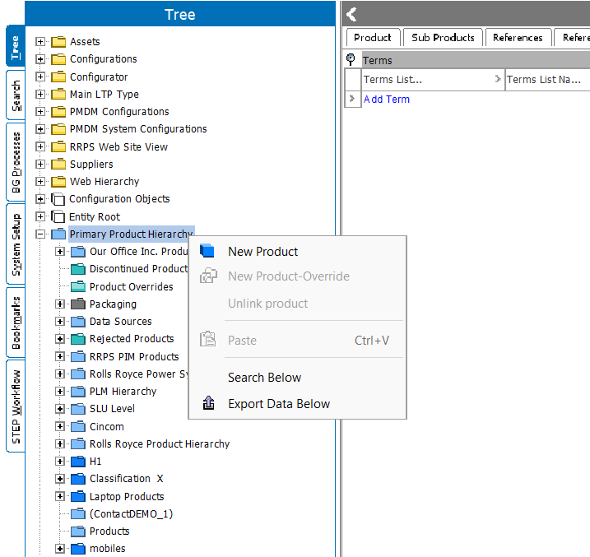

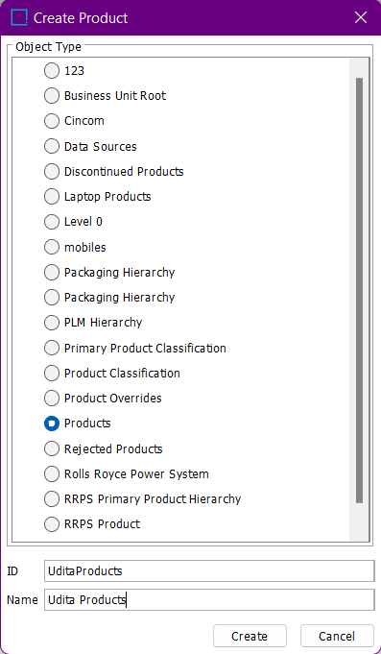

* Right Click on Udita Products -> New Product.

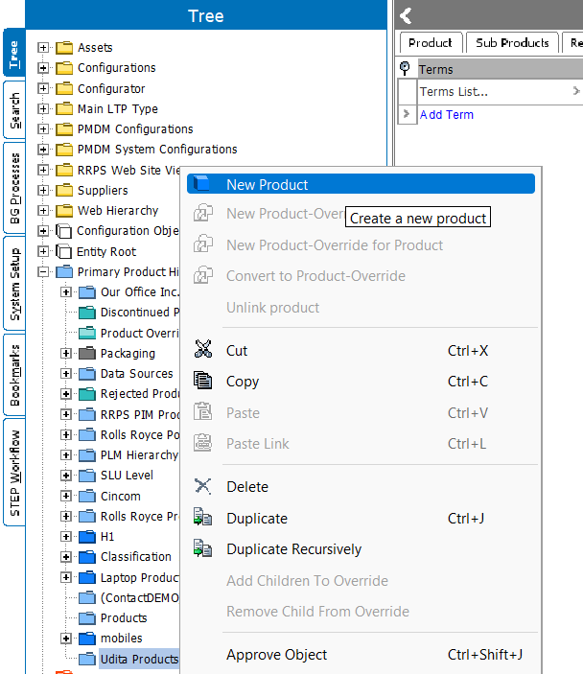

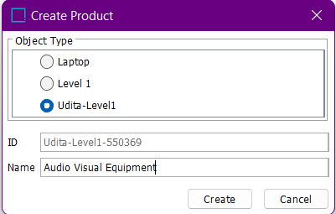

* Right Click on Audio Visual Equipment -> New Product.

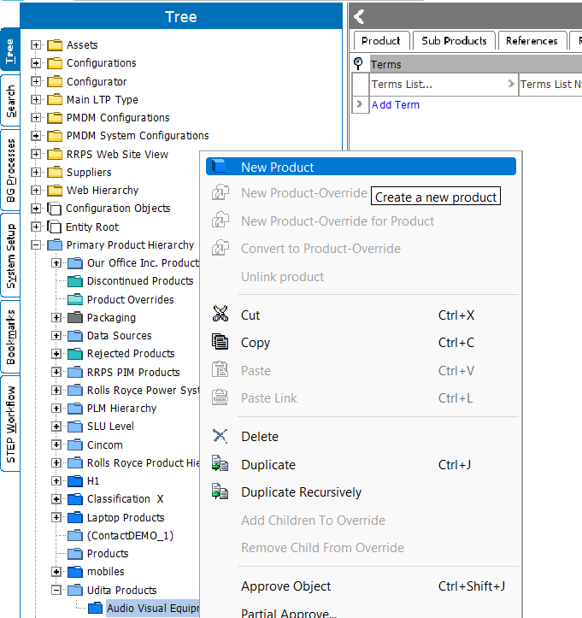

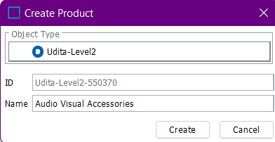

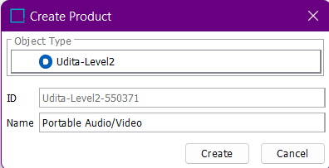

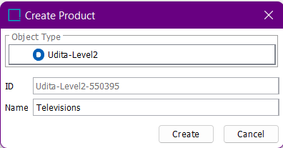

* Finally, it looks like :

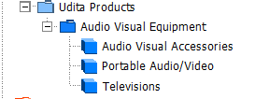

**Exercise 03 : Category Specific Analysis.**

**Solution :**

**Exercise 04 : Define Additional Required Object Types.**

**Solution :**

* Select System Setup -> Object Types & Structures-> Products.
* Right Click on Udita-Level2-> New Object Type.

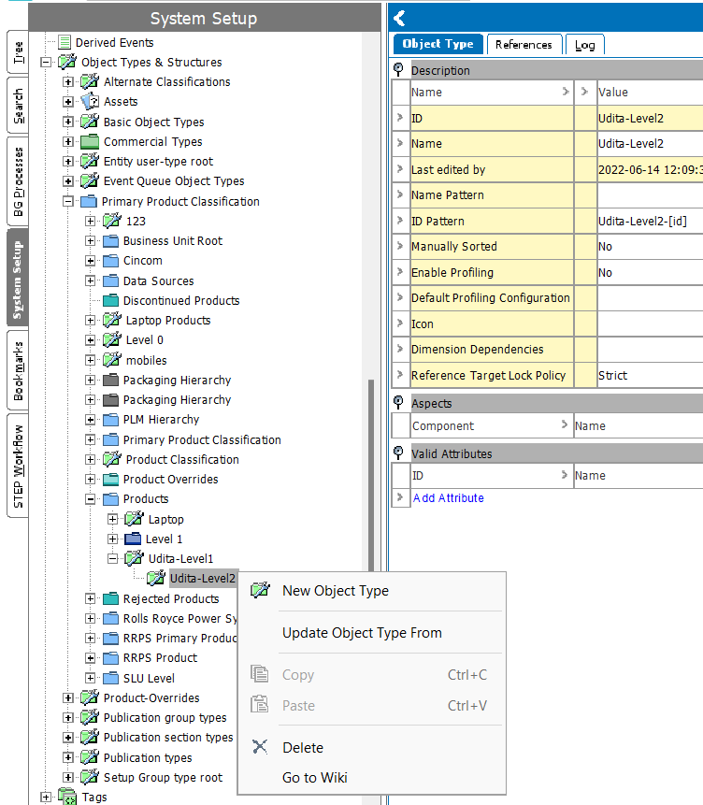

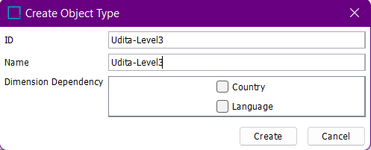

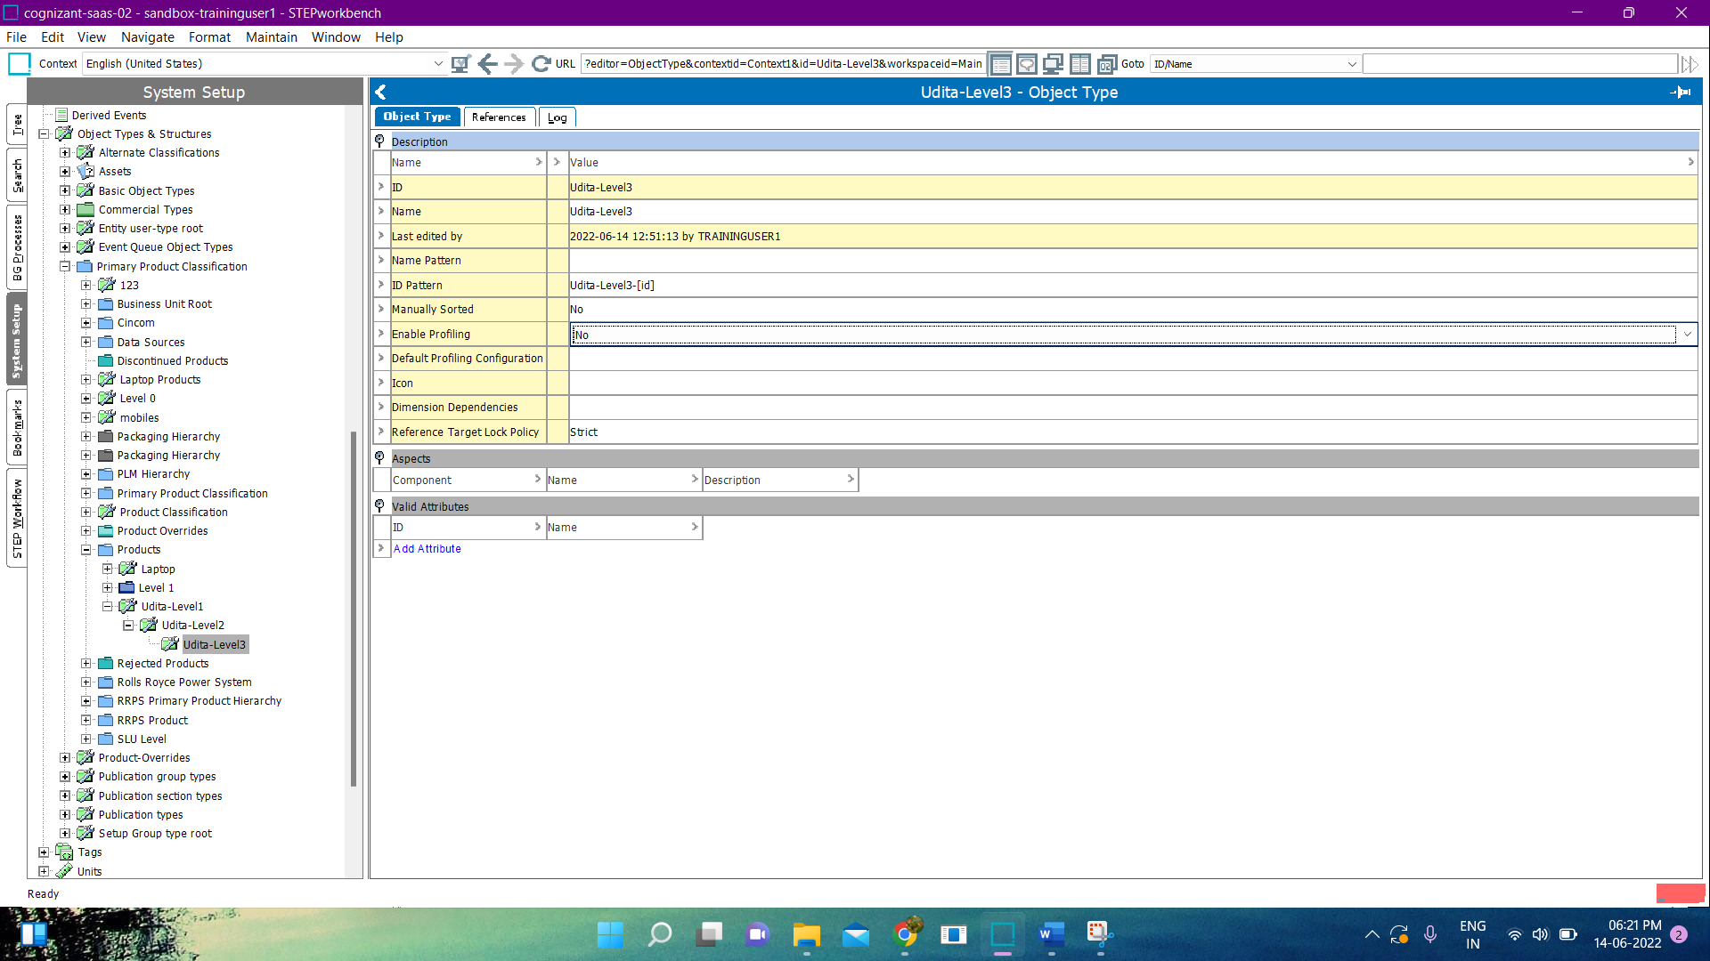

* Right Click on Udita-Level3-> New Object Type.

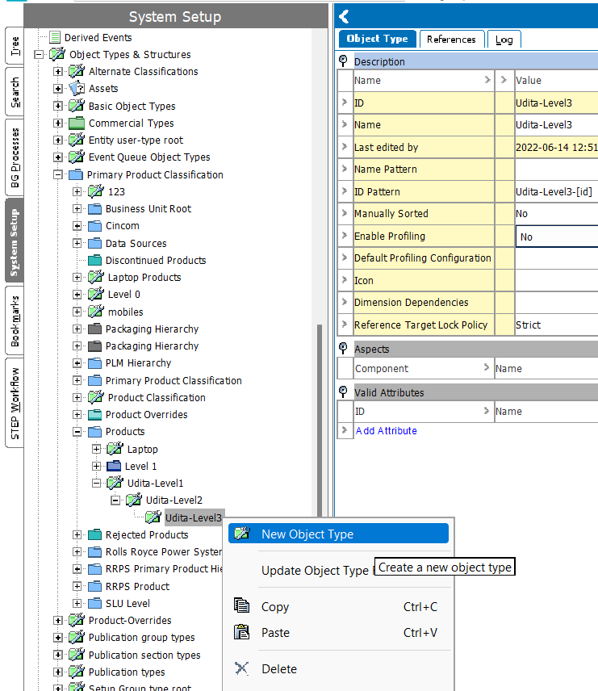

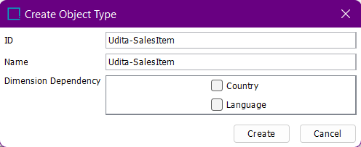

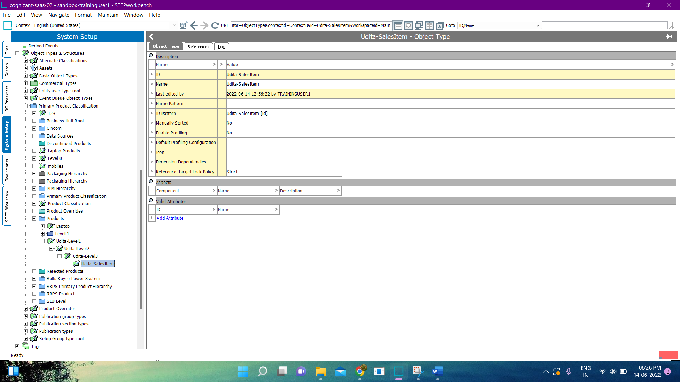

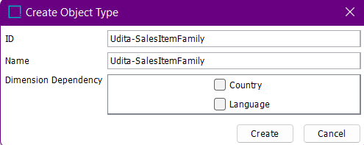

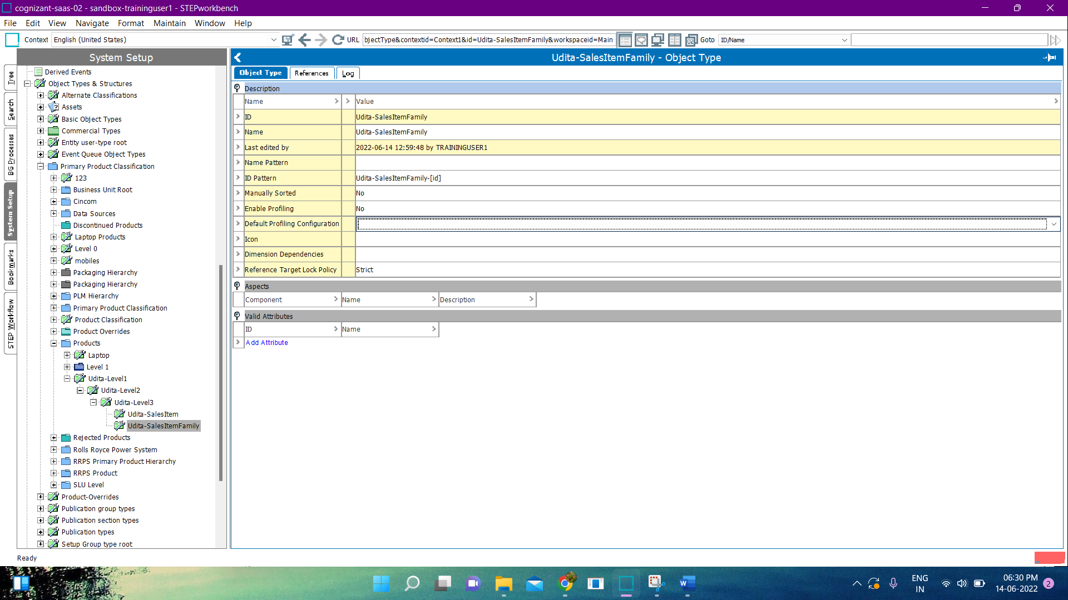

* Right click on Udita-SalesItemFamily -> New Object type.

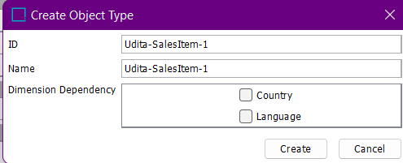

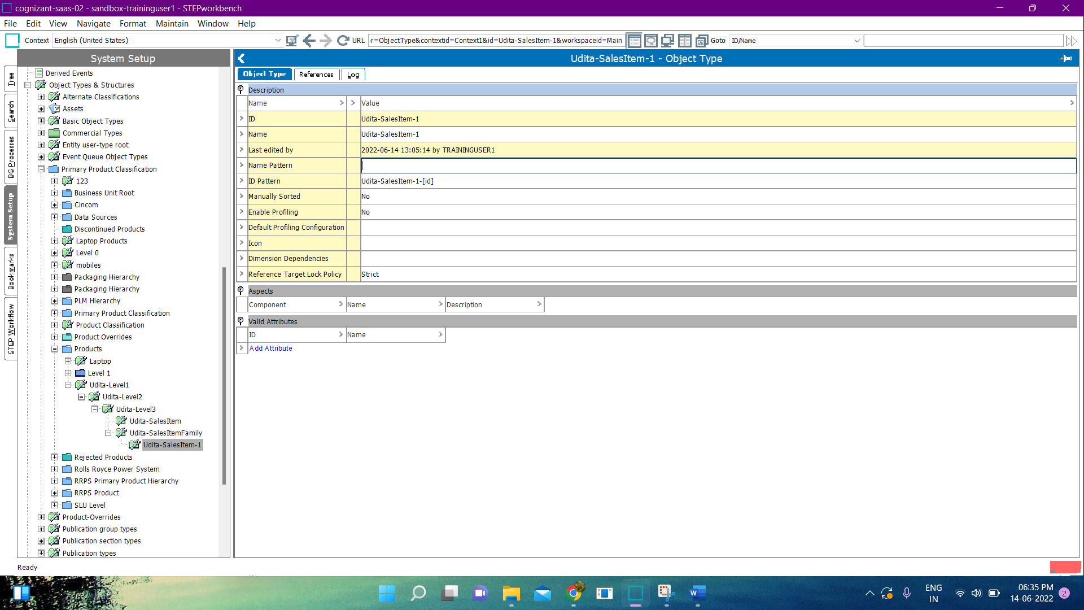

* ID Patterns are :
* Udita-Level3:

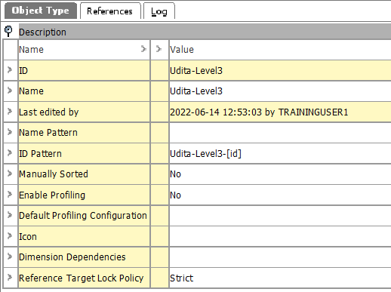

* Udita-SalesItem :

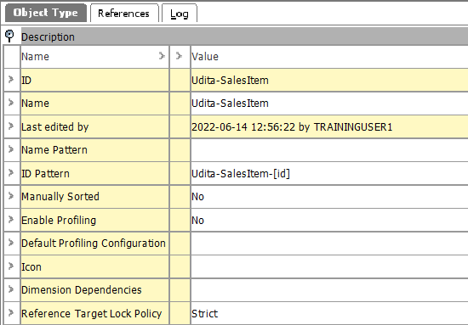

* Udita-SalesItemFamily :

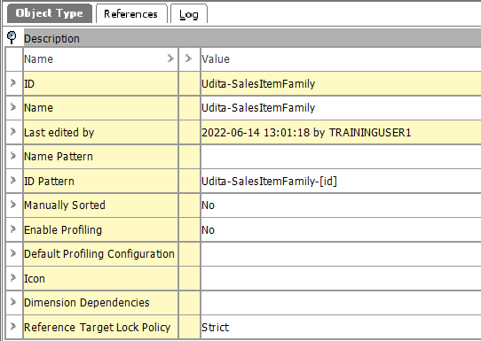

* Udita-SalesItem-1:

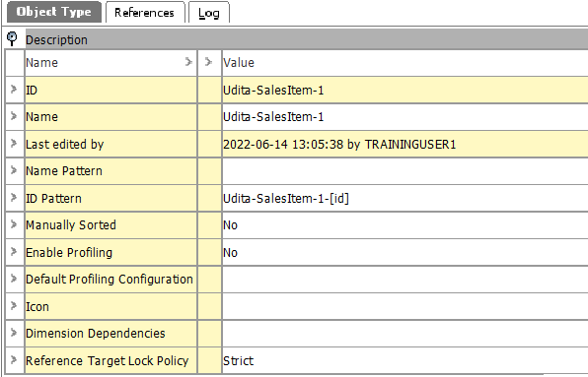

* Finally, it looks like :

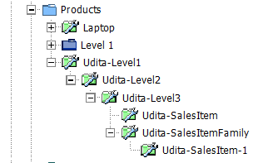

**Exercise 05 : Create Portable Audio/Video Products.**

**Solution :**

* Go to Tree -> Primary Product Hierarchy -> Udita Products -> Audio Visual Equipment -> Portable Audio/Video.
* Right click on Portable Audio/Video-> New Product.

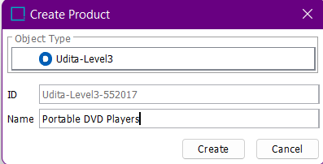

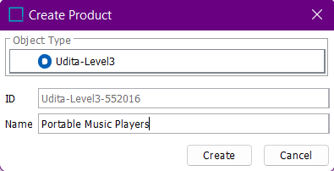

* Right click on Portable Music Players -> New Product.

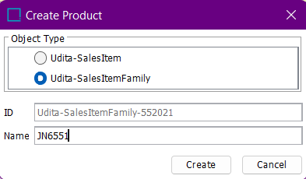

* Right click on JN6551-> New Product.

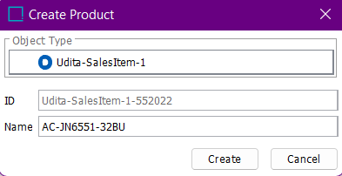

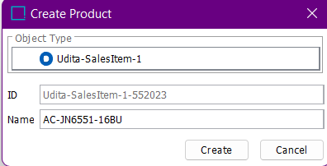

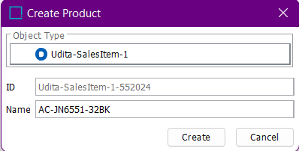

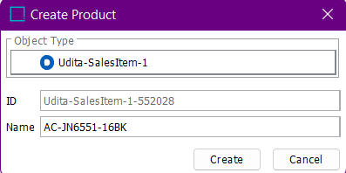

* Right click on Portable DVD Players -> New Product.

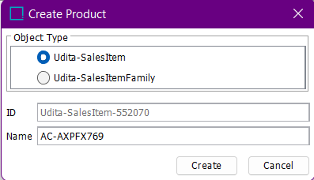

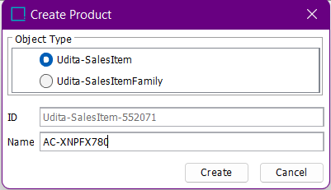

* Finally, it looks like :

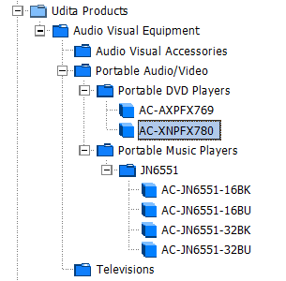

**Exercise 06 : Attribute Analysis.**

**Solution :**

**Exercise 07 : Create Attributes.**

**Solution :**

* Go to System Setup -> Atrribute Groups -> Category Specific Attribute.
* Right Click on Category Specific Attribute -> New Attribute.

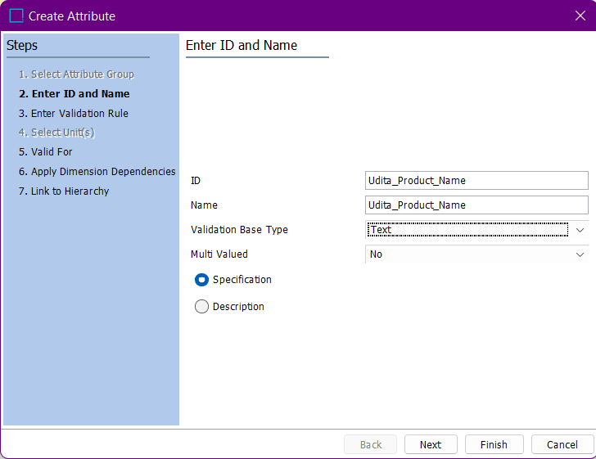

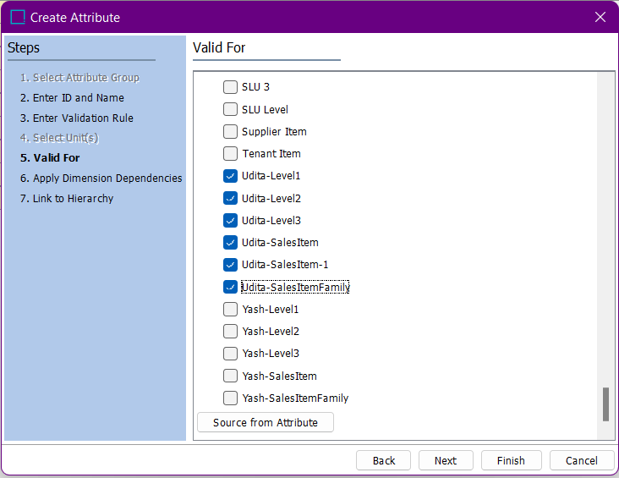

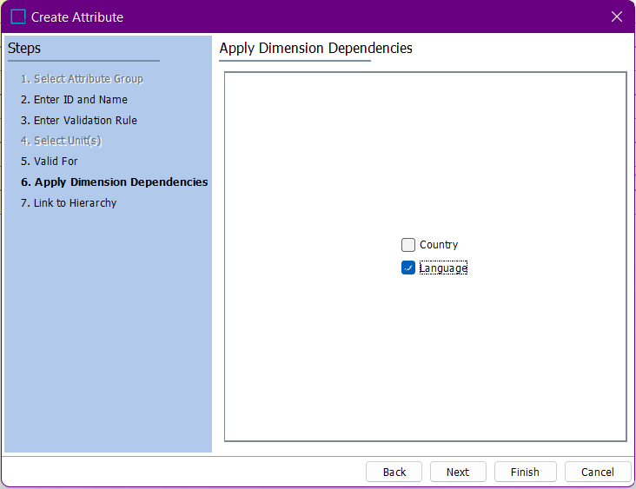

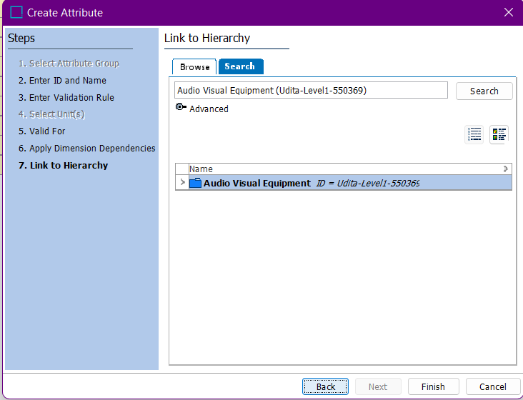

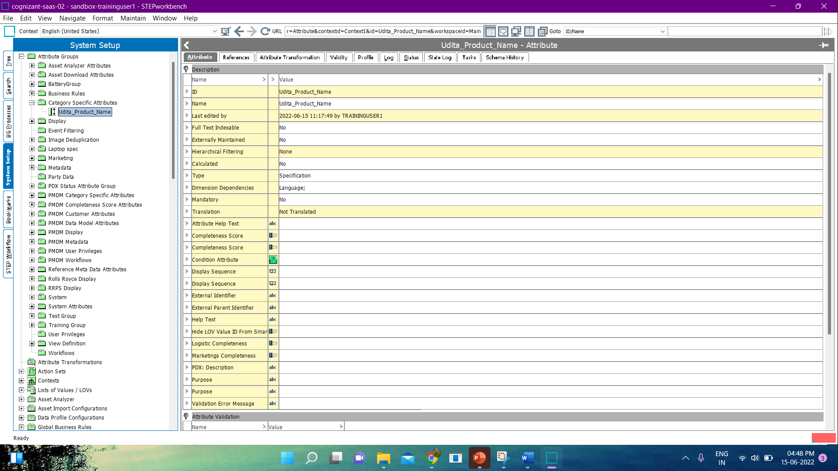

* Right click on MetaData -> New Attribute.

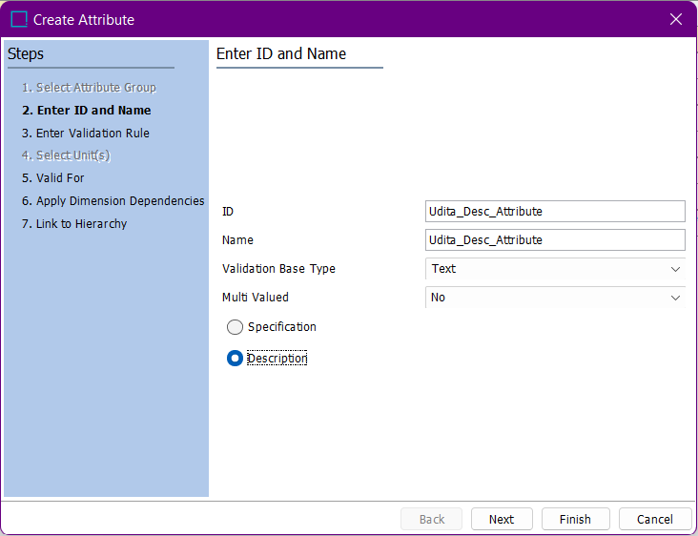

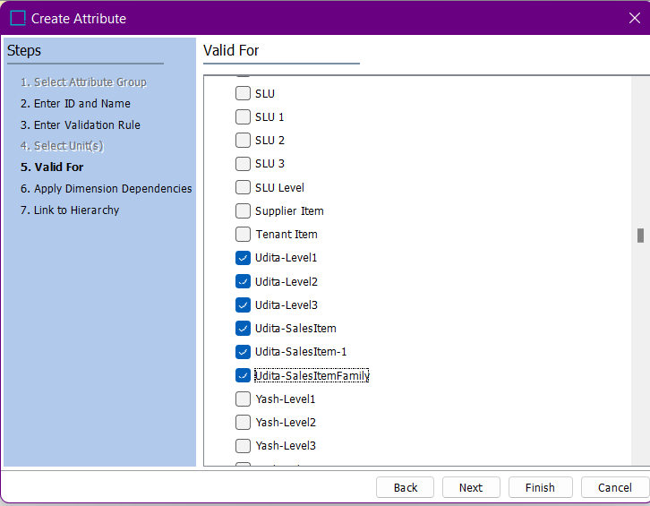

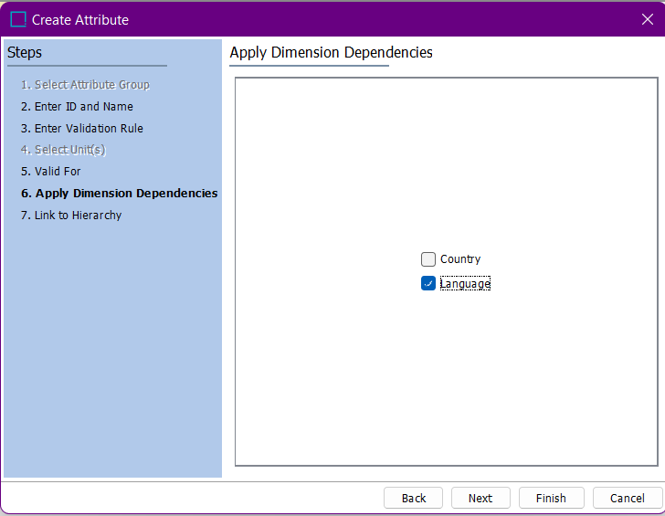

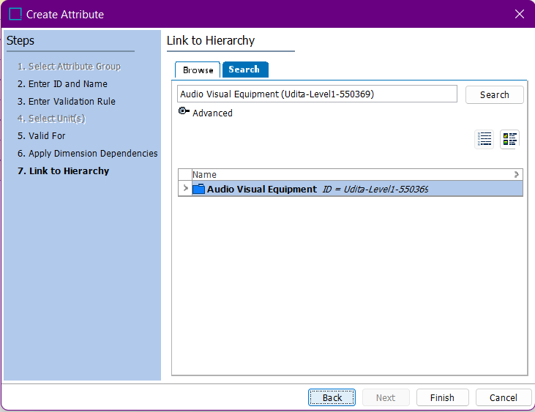

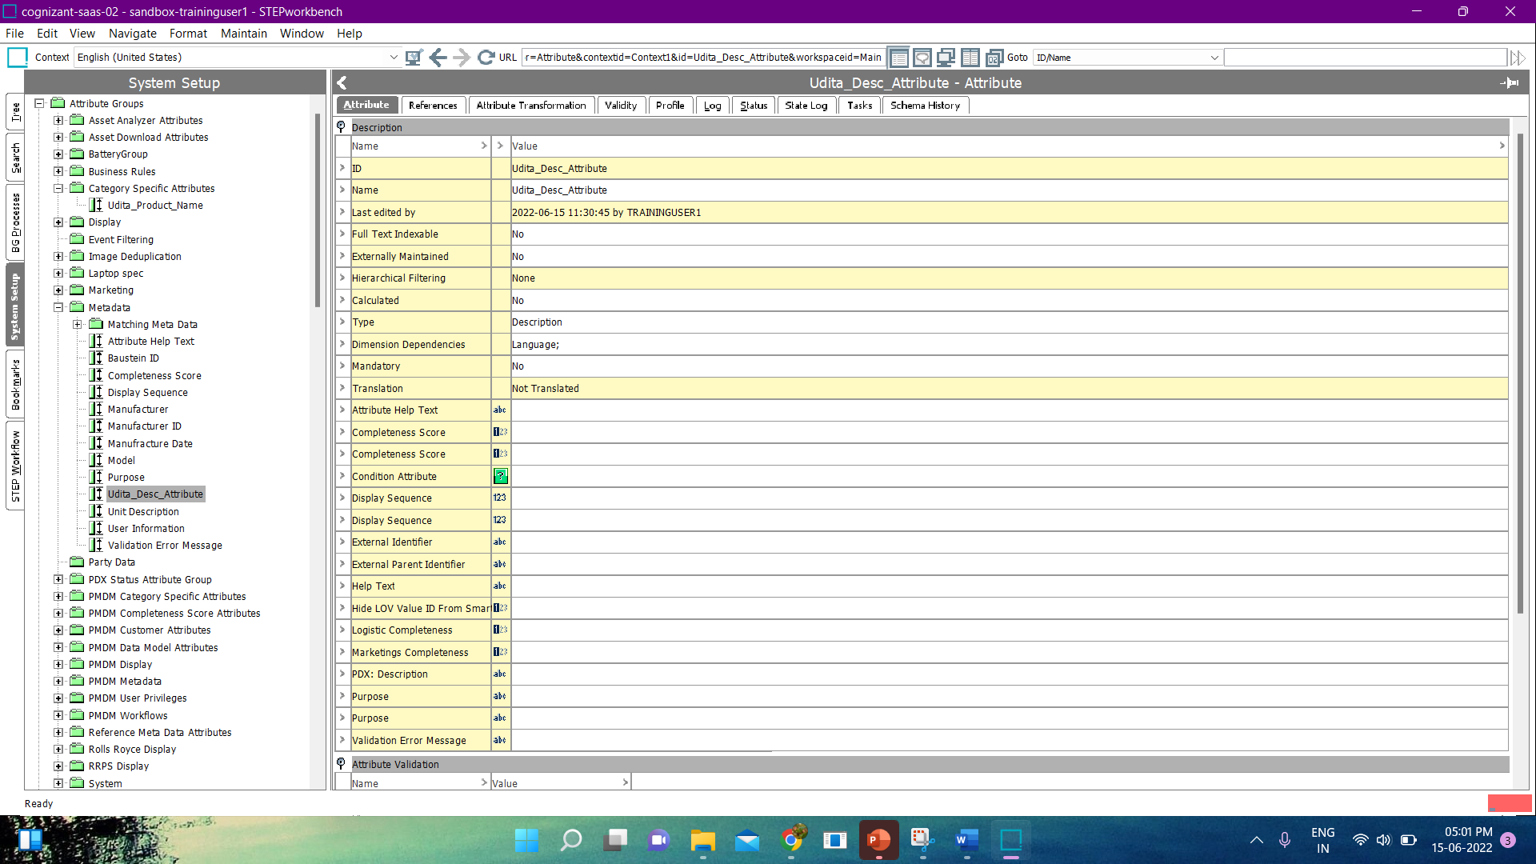

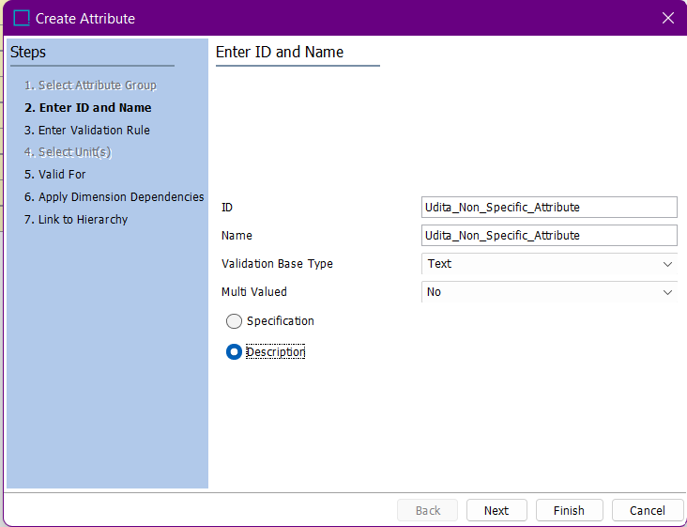

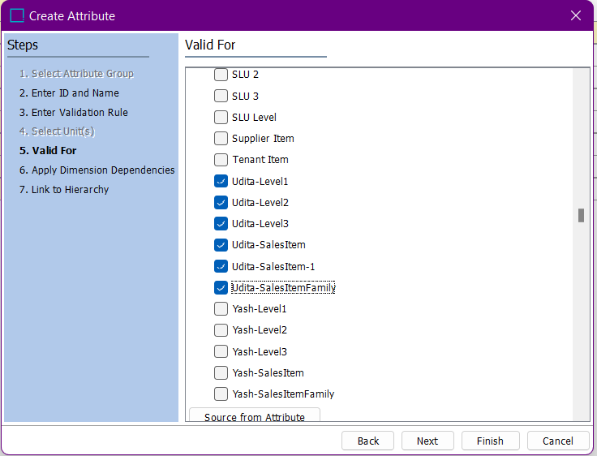

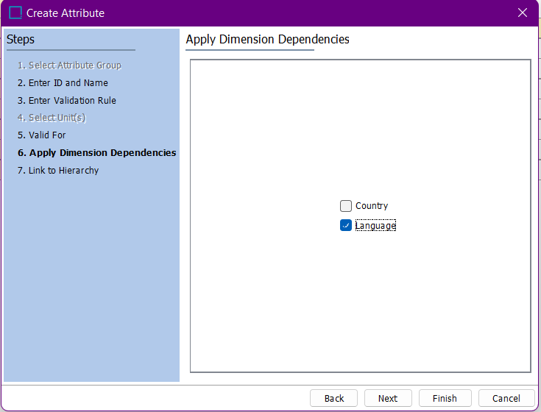

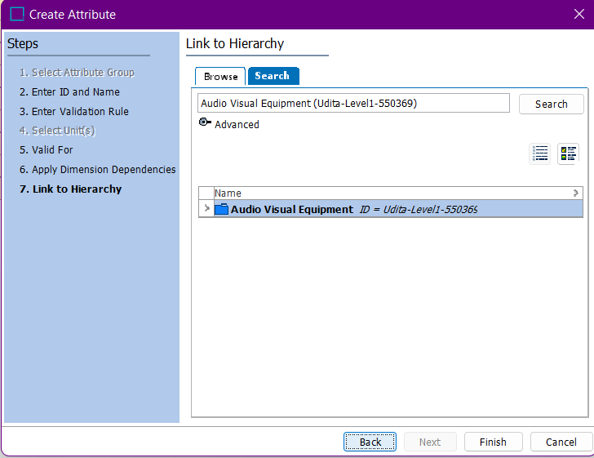

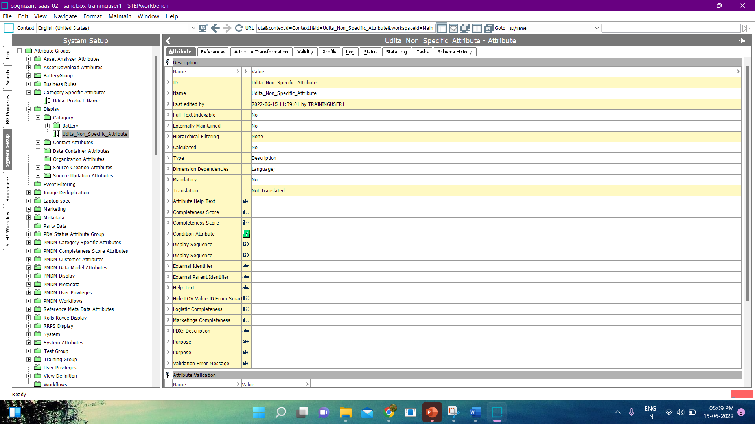

* We can check our newly added attributes in Tree.

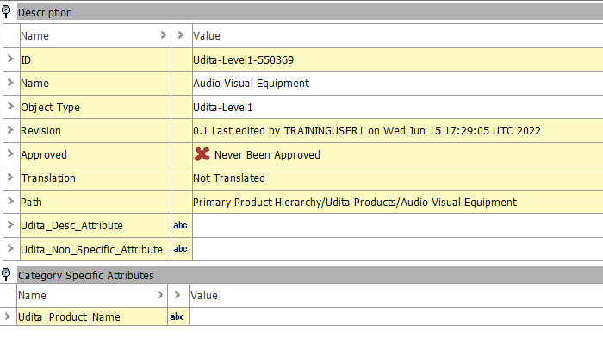

**Exercise 08 : Create New Product Reference Type.**

**Solution :**

* Go to System setup -> Reference Types -> Product Reference Types.
* Right click on Product Reference Types -> New Product Reference Type.

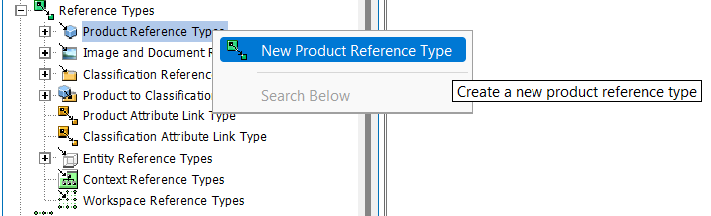

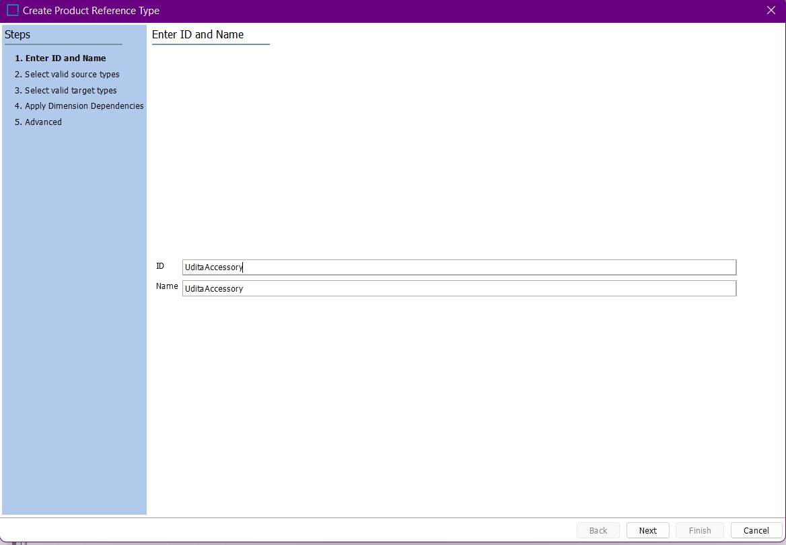

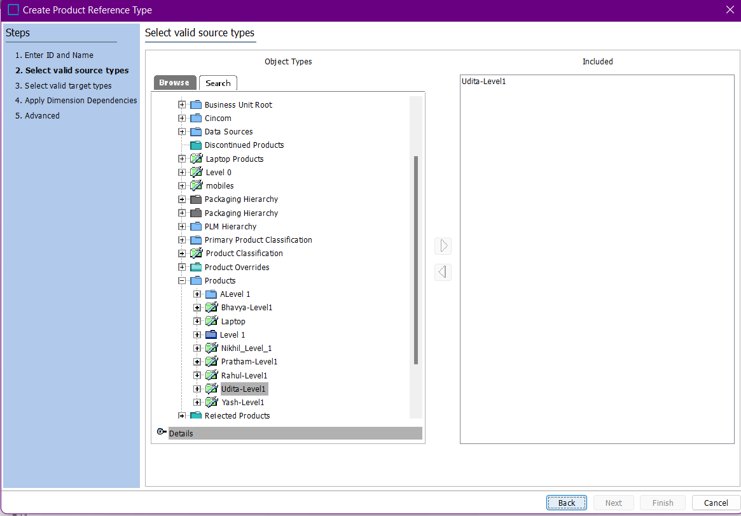

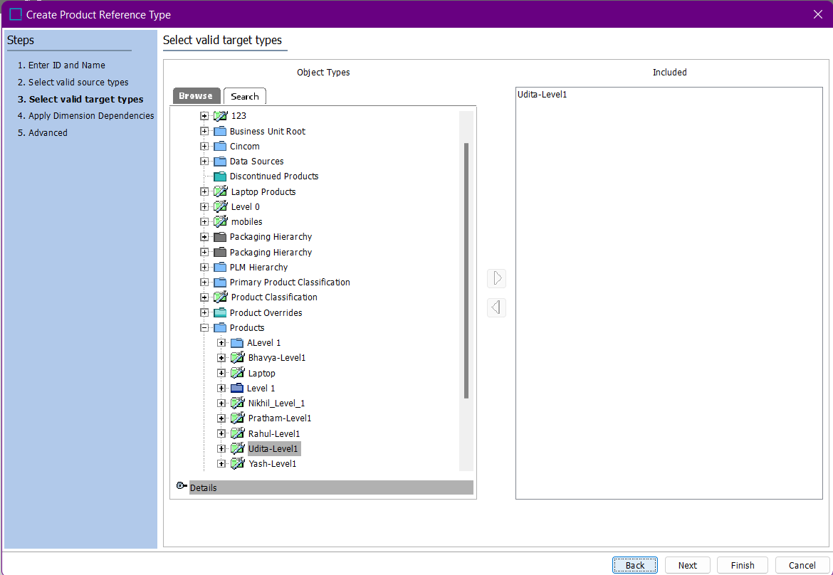

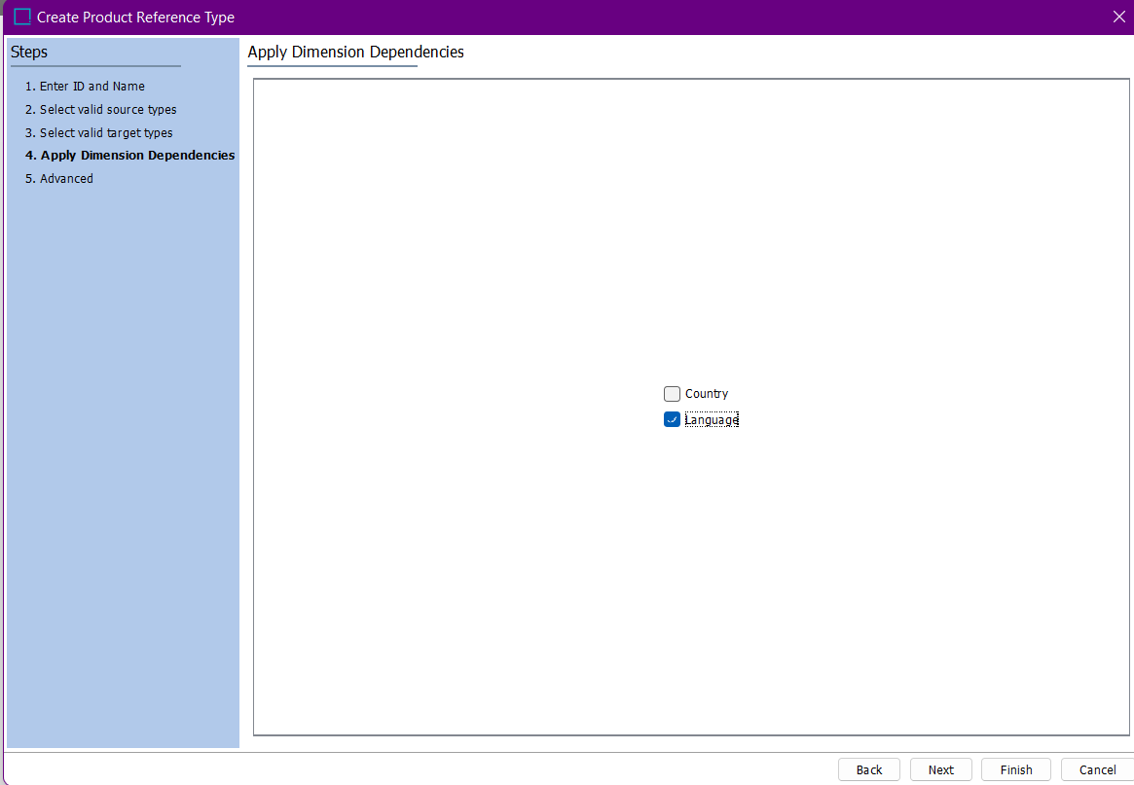

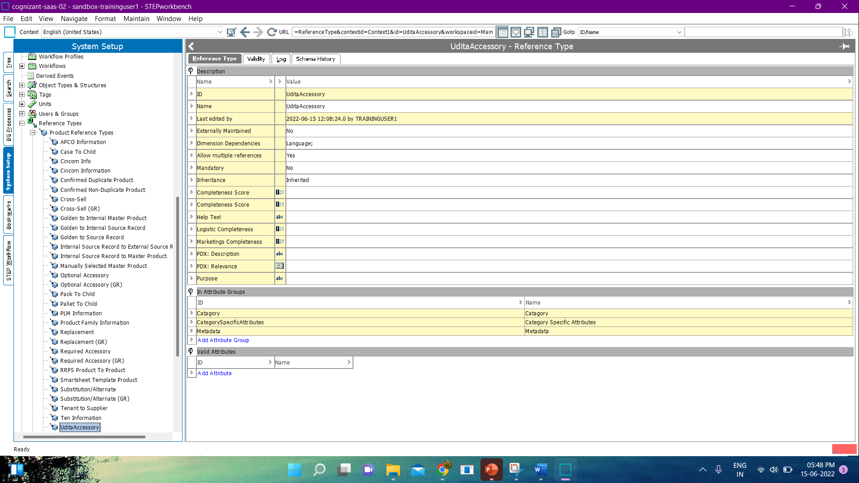

* Go to Tree -> Udita Products -> Audio Visual Equipment -> References Tab.

